**Control Flow and Built in Data Structures**

1. Write a code to filter all sub-strings which have an even number of vowels?

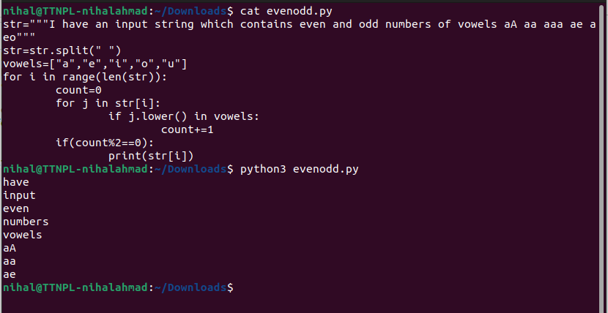

2) Programming: From a multi-words and multi-line string, prepare a dict with key as "word" and value as occurrence of word.

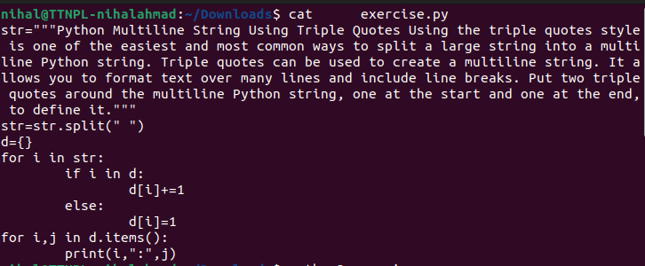

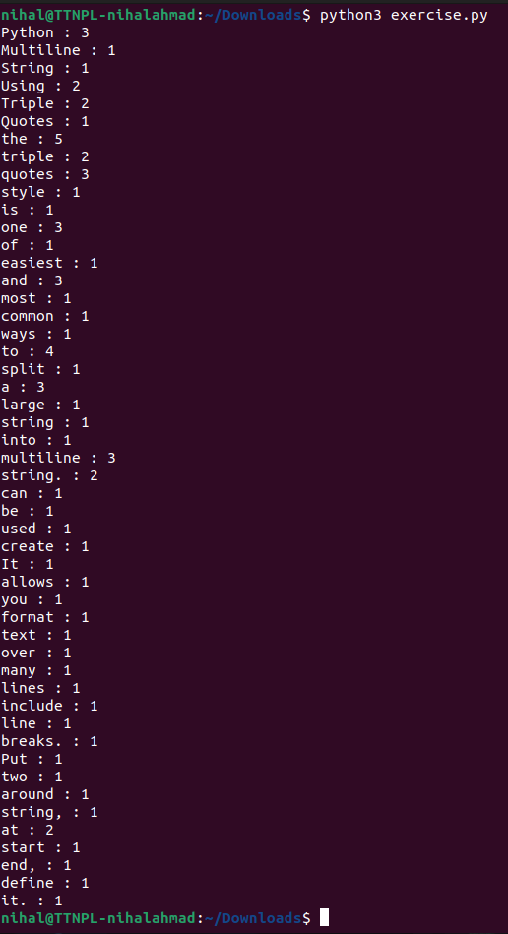

3) Programming: From a multi-words and multi-line string, prepare a filter for the list of words which have multiple occurrences in the string.

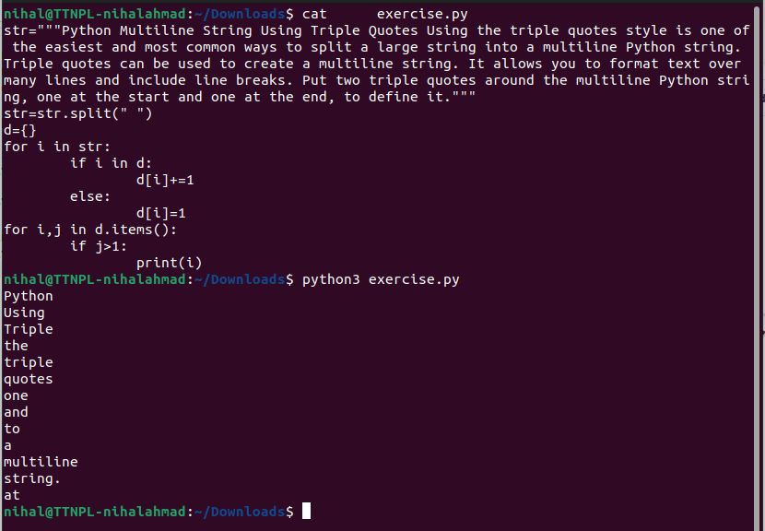

4) Programing: From a multi-words and multi-line string, display list of words and word's length with occurrence more than 1 in sorted order

